**Ideation Phase**

**Brainstorm & Idea Prioritization Template**

|  |  |
| --- | --- |
| Date | 31 January 2025 |
| Team ID | SWTID1743353335 |
| Project Name | Book a doctor using MERN |
| Maximum Marks | 4 Marks |

**Step-1: Team Gathering, Collaboration, and Selecting the Problem Statement**

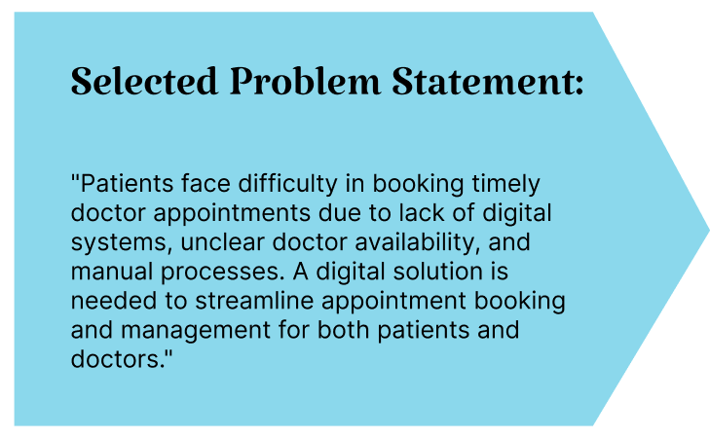

|  |  |
| --- | --- |
| **IDEA** | **GROUP** |
| Allow search/filter of doctors by specialization | User Convenience |
| Create user roles: Patient, Doctor, Admin | Core Functionality |
| Build doctor profiles with rating, availability, and bio | Transparency |
| Implement appointment booking with slot selection | Booking System |
| Use JWT for authentication and role-based access | Security |
| Admin approval for doctor registration | System Integrity |
| Real-time status updates for appointments | Communication |

**Step-2: Brainstorming, Idea Listing, and Grouping**

